Understanding the Minnesota Judiciary: Legislators and Judges are Different

Lesson Plan

Abstract: Students will learn that judges and legislators have different roles to play in our system of government by analyzing a case study that describes the development and application of the Minnesota Move Over traffic law, which requires that drivers move over a lane when approaching a squad car involved in a traffic stop. Students will storyboard the steps taken as the law moves from the legislature through the three levels of the court system and then back to the legislature. Lesson includes a student reading and comparison chart.

Objectives:

1. The students will describe the differences between judges and legislators and the functions each performs.
2. The students will understand how laws are developed by the legislature and applied and
interpreted by the courts.
3. The students will understand the difficulty of writing laws that are clearly understood.
4. The students will understand the difficulty of interpreting laws that can be given different interpretations.

Grade Level: High School

Time to Complete: One to two class periods

Materials Needed: Student Handouts: Legislators and Judges are Different and the Traffic Law Case Study; Construction paper, colored pencils, markers, Minnesota Constitution, Minnesota Legislative Manual, Move Over Card,

Procedure:

1. Introduce the topic by discussing how citizens go to different branches of government with concerns. How are the branches different in the way they do their work? How are the legislators and judges different? Have students review powers delegated in the Minnesota and US Constitutions.

Suggested lesson talking points:

Legislators look forward and judges look back: limited to using a record developed by parties, applying precedents, looking for legislative intent.
Legislators can pursue policy interests and agendas; judges take cases brought to them. Judges apply the law written by legislators, even when they might personally dislike the law. Legislators change the law when they don’t like it.

Legislators represent constituent interests; judges apply the law to the facts of a case. They do not represent constituent interests and sometimes decide cases against the will of the majority of citizens.
There are no education requirements to be a legislator and the legislature includes people from all backgrounds and walks of life. Judges have the same educational background: they must be
learned in the law and have a license to practice law.

2. Have students complete to the best of their ability the “Legislators and Judges are Different “chart.
They will return to this at the end of the lesson.

3. Optional Warm Up Activity

1. Misunderstandings: Walk around the class and talk to other students about a time when you or someone you know misunderstood the meaning of something. Change partners often.

2. Chat: In pairs / groups, decide which of these topics or words that will be in the reading are most interesting and which are most boring. Have a chat about the topics you like.

Prosecutor/alcohol concentration level/ exclusionary rule/ reasonable interpretation/ DWI

4. Storyboard Activity. Divide students into groups of six for the “Traffic Law Case Study” storyboarding activity. A storyboard is a visual representation that depicts (explains) what is sequentially happening in a written story.

5. In each group of six, assign one student to each of the first six chapters of the “Traffic Law Case Study”. The case study includes six chapters plus a final seventh chapter that will be considered at the end of the storyboarding activity.

Plot lines of case study

Chapter 1 – The law is developed

Chapter 2 – The story of the case

Chapter 3 – The case goes before the District Court

Chapter 4 – The Court of Appeals hears the appeal

Chapter 5 –The case is appealed again to the Minnesota Supreme Court

Chapter 6 – The Fix by the Legislature

Chapter 7 – Students predict future situations

6. Provide instructions for storyboarding.
a. When creating a storyboard using a non-media source, students should be provided with at least a 12 x18 sheet of construction paper. Have students fold their paper in half lengthwise. Next, have students fold their paper into thirds. Have students unfold their paper. The student’s paper will now be divided into six equal squares.

b. Have students read their assigned chapter of the story. Using a storyboard visually show what is happening in the chapter. Make sure to use all six squares of the storyboard. Pictures should be neat, clear, and be able to help explain what is going on in the chapter.

Storyboard options: Pictures from magazines, books, internet, and/or other published materials may be used. A storyboard can also be created using a PowerPoint.

7. Have students share their storyboards with other members of their group. In their groups, have students predict what might happen next. Ask students to represent their predictions in a picture with a short description. They may each do their own prediction or produce one prediction for the group.

8. Have students share their storyboards with the large group. Present first six chapters first. After the whole class has shared, have them present their Chapter Seven predictions.

9. Review the roles played by the legislative and judicial branches in the case study. Have students review their “Legislators and Judges are Different” chart, making corrections and additions.

10. Optional Activity: Discuss qualifications/personality traits that would be desirable for legislators and judges. How are they the same, different? Describe perfect candidates for each.

This lesson plan was developed as part of a curriculum-development workshop that was sponsored by the Minnesota Supreme Court Historical Society, with the assistance of the Minnesota Supreme Court, the Minnesota State Bar Association Civic Education Committee, and the Learning Law and Democracy Foundation. Lesson development was supported in part with funds from the Arts and Cultural Heritage Fund of the Clean Water, Land, and Legacy Amendment to the Minnesota Constitution, which Minnesotans passed into law via the 2008 general election ballot.

STUDENT HANDOUT: Legislators and Judges are Different

Roles of Legislators and Judges Are Different

Legislators and judges play different roles in our system of government. To show you understand this, fill in the chart using the phrases below. Place all phrases that describe concepts/roles of the legislature in the column titled Legislative Branch and all concepts/roles of the judiciary in the column Judicial Branch. All blanks in the chart will not be filled.

Phrase Bank:

Look forward Look back
Apply precedents Change laws they don’t like Pursue policy No educational requirements Take cases brought to them Choose problems to work on
Come from a variety of occupations/jobs Apply the law without regard to personal views
Elected to two or four year terms Must be learned in law/have license to practice law
Represent interests of constituents Writes statutes
Writes opinions that explain reasoning Elected to six year terms
Governor can appoint to fill vacancy

Roles
Legislative Branch | Judicial Branch

Traffic Law Case Study

Chapter One: The Law
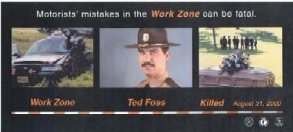

"Ted Foss" Move Over Law

In August 2000, State Trooper Ted Foss was killed when a semi-truck accidentally crashed into his squad car and another car stopped on the side of the road.

As a result of this crash and other similar ones, the Minnesota Legislature passed the “Ted Foss” Move Over Law in 2002. In order to keep officers safe, this law requires drivers to move their cars a lane over when they are driving near an officer who is making a traffic stop.

2002 Minnesota Statutes §169.18, subd. 11, reads:

“When approaching and before passing an authorized emergency vehicle that is parked or otherwise stopped on or next to a street or highway having two or more lanes in the same direction, the driver of a vehicle shall safely move the vehicle to a lane away from the emergency vehicle.”

To teach the public about the law, the MN Dept of Public Safety wrote a brochure that put the law in simple terms:

If you are traveling on a roadway with two of more lanes, you must keep a lane away when passing a stopped ambulance, fire truck, or law enforcement vehicle. If you are not able to safely move a lane away, reduce your speed.
If you fail to take these actions you could receive a citation.

Ignoring this law endangers the law enforcement officers, firefighters, emergency medical personnel, and tow truck drivers who provide critical — and sometimes lifesaving — services on Minnesota roadways.

The next time you see flashing lights up ahead, remember to move over. Obeying this little-known law could make a big difference.

Always remember to buckle up.

Chapter One Review Questions:
Please answer on a separate sheet of paper.

1. Which branch of government is at work here?

Circle one: Legislative Executive Judicial

2. What action did the branch take?

3. What is your understanding of what the law says? Summarize it.

4. Why was the law passed?

5. What is the purpose for the law?

Chapter Two: The Case

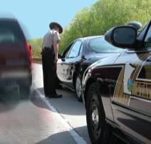

On February 7, 2003, a University of Minnesota police officer pulled over a car for a traffic violation on University Avenue in Minneapolis. University Avenue is a one- way street with three lanes of traffic. There is a paved bicycle lane next to the right curb. The officer parked his squad car behind the stopped car and turned on his emergency lights. In doing so, his squad car partially occupied the right lane of traffic. The officer got out of his squad car and went to talk to the driver of the stopped vehicle.

While walking back to his squad car, the officer saw a vehicle coming toward him on University Avenue in the center lane. This approaching vehicle, driven by Anderson (the defendant), had signaled a lane change and moved into the center lane to avoid the officer and his squad car.

Believing that Anderson’s vehicle passed too close to him and his stopped squad car, the officer got into his squad car, pursued Anderson, and then stopped him. The officer told Anderson that he broke the Move Over Law (Minn. Stat. §169.18, subd. 11). The officer believed that Anderson was in violation of this law because he thought it was illegal for Anderson to pass the stopped squad car without allowing “a buffer (extra)
lane of traffic” between the two vehicles.

When the officer was talking to Anderson, he thought that Anderson might be drunk and gave him a breath test to be sure. Due to the test result, the officer arrested Anderson for impaired driving. The state charged Anderson with Driving While Impaired (DWI) in the Fourth Degree (driving with an alcohol concentration of .10 or more, 2002 law). He was not charged with breaking the Move Over Law.

Facts from Minnesota v. Anderson, MN Supreme Court A03-290. July 29, 2004.

Chapter Two Review questions:

1. Draw the scene of the traffic stop on a separate sheet of paper.

2. Which branch of government is at work here?

Circle one: Legislative Executive Judicial

3. What was the officer doing when Anderson drove by?

4. Why did the officer stop Anderson?

5. Why did the officer arrest Anderson?

6. Why is Anderson going to court?

Chapter Three: The District Court

Anderson pleaded not guilty to the DWI charge in District Court. In a pre-trial hearing, Anderson’s lawyer and the state’s lawyer (prosecutor) made arguments before a district court judge about whether or not the blood test results should be allowed as evidence against Anderson in the trial.

Anderson’s lawyer argued that the blood test results should not be allowed as evidence in his trial because the police officer did not have a valid reason for stopping his car. If the officer did not have a valid reason to stop the car, the judge can apply the exclusionary rule which would keep out of the trial any evidence obtained during the invalid stop.

The officer testified that he pulled Anderson over because he failed to move over to the proper lane required by the Move Over Law. Anderson argued that he was in the “lane away” even though it wasn’t the furthest lane.

The prosecutor argued that the evidence obtained (alcohol concentration level) should be allowed at trial because the police officer had made a valid stop. He said the officer believed the law required Anderson to leave a buffer lane and that his reasonable interpretation of the law’s meaning was a valid reason to stop the car.

The district court judge ruled in favor of Anderson. He decided there was no valid basis for the stop by concluding that Minn. Stat. §169.18, subd. 11 is clear when it says “a lane away” and does not require motorists to provide a buffer lane between themselves and parked emergency vehicles.

State v. Anderson, 671 N.W.2d 900 (Minn App. 2003) granting motion to strike Hennepin County District
Court File No. 03009871.

Chapter Three Review questions:
Please answer on a separate sheet of paper.

1. Which Minnesota court is deciding this question?

2. What is the question the court must decide?

3. What constitutional protection is involved in this case?

4. If the police officer breaks the rules, what happens to the evidence?

5. Who are the people arguing before the judge?

6. Who is the winner in the first case? Why?

Chapter Four: The Minnesota Court of Appeals

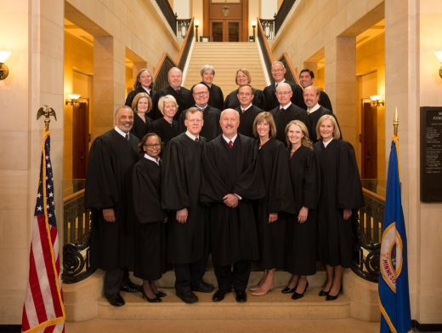

The state disagreed with the conclusion of the District Court and asked a higher court to look at the case (appealed). In December of 2003, the Minnesota Court of Appeals reversed the district court’s decision and ruled that the officer’s stop was legal because he had a reasonable interpretation of the “move over” law.

On the Minnesota Court of Appeals, a three-judge panel reads the legal arguments from both sides and then listens to both lawyers make oral arguments. The judges often interrupt lawyers and ask questions to better understand the case. Then they meet and make their decision.

In this case, the Court of Appeals issued an opinion (a written decision explaining the court’s reasoning) that said the Move Over Law is ambiguous (open to more than one interpretation) and the phrase “a lane away” could mean either in the next lane or a full lane away. The Court concluded that it is not clear what the legislature meant. They ruled that the evidence should be allowed in Anderson’s trial because the officer’s interpretation of the Move Over Law is a reasonable one when considering the totality of the circumstances.

State v. Anderson, 671 N.W.2d 900 (Minn App. 2003).

Chapter Four Review questions:
Please answer on a separate sheet of paper.

1. Which Minnesota Court is deciding this question?

2. How many judges make the decision?

3. What are the steps in making the decision?

4. Who is the winner at this level court? Why?

Chapter Five: The Minnesota Supreme Court

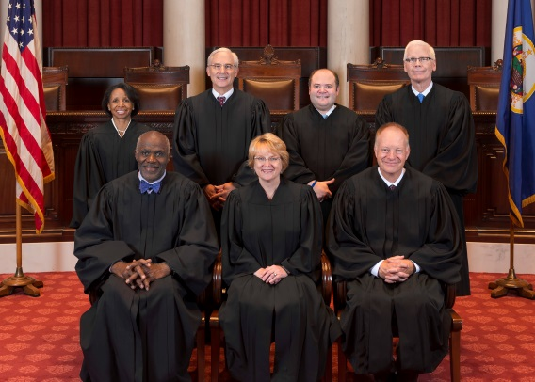

The case was appealed again. In July 2004, the seven justices of the Minnesota Supreme Court, the court of final review on Minnesota law, followed a process similar to that of the Court of Appeals, and issued a decision reversing the Court of Appeals and agreeing with the District Court.

The Minnesota Supreme Court decided that the “natural and obvious usage” of the phrase “a lane away” is clear; it means “in the lane next to” the stopped emergency vehicle. Since Anderson’s car was completely within the center lane of traffic, it was in the lane next to the lane occupied by the officer’s stopped squad car. The court ruled that Anderson did not violate the Move Over Law.

The Court said that even if the officer acted in “good faith,” he incorrectly interpreted the Move Over Law and did not have an objective basis to justify the stop. The Minnesota Supreme Court upheld the District Court’s decision to exclude the evidence obtained as a result of the invalid stop.

State v. Anderson, Minn Supreme Court A03-290, decided July 29, 2004

Chapter Five Review questions:
Please answer on a separate sheet of paper.

1. Diagram the Minnesota court system showing all three levels of courts and who won at each court.

2. What question is before this court?

3. Who is the winner at this level of court? Why?

Chapter Six: Fixing the Law

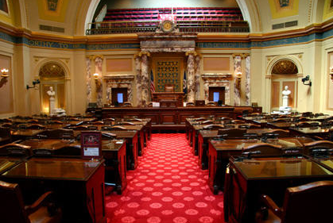
During the 2005 legislative session, the "Move Over Law" was amended (changed). Minnesota Statutes §169.18, subd. 11, now reads:

"(a) When approaching and before passing an authorized emergency vehicle with its emergency lights activated that is parked or otherwise stopped on or next to a street or highway have two lanes in the same direction, the driver of a vehicle shall safely move the vehicle to the lane farthest away from the emergency vehicle, if it is possible to do so.

(b)When approaching and before passing an authorized emergency vehicle with its emergency lights activated that is parked or otherwise stopped on or next to a street or highway having more than two lanes in the same direction, the driver of a vehicle shall safely move the vehicle so as to leave a full lane
vacant between the driver and any lane in which the emergency vehicle is completely or partially parked or otherwise stopped, if it is possible to do so."

Note: The Minnesota Department of Public Safety updated the Ted Foss Move Over Law materials to explain the 2005 change. The official website says “When traveling on a road with two or more lanes, drivers must keep over one full lane away from stopped emergency vehicles with flashing lights activated — ambulance, fire, law enforcement, maintenance and construction vehicles.

Chapter Six Review questions:
Please answer on a separate sheet of paper.

1. In what ways did the Legislature change the Move Over Law?

2. Did the changes solve the problem?

3. Do you see any new problems with the law?

4. Do you think that the language on the Minnesota Department of Safety’s website correctly explains the changes the legislature made in the law? Please explain.

Chapter Seven: You predict what happens next

What is a possible next chapter for the Move Over Law? Storyboard your idea and explain in a small paragraph what happens.

