VISITOR FROM OUTER SPACE

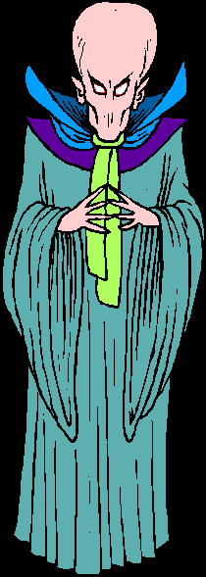You are watching TV one night when all of a sudden a strange looking creature appears on the TV and says:

My name is STHGIR and I am from another planet in another galaxy where the people are far superior to the beings on planet EARTH. My people have gained control over your government. We have the ability to take control of your lives.

We do not want a war between our planet and yours, but we do need to control some things so that we can live in harmony with you. We believe you have too much freedom. We need to take some of your rights away. We would like to come to a decision that we can both be happy with.

Therefore, I am giving you a list of ten of the rights that you now have. Look over the list and decide which five you want to keep. If you do not decide, I will decide for you.

To help you make your selection, rank the rights listed below in the order of importance, with 1 being the right you value most and would give up last and 10 the right you think is least important and would give up first.

____Right to bear arms

___Right to protection from cruel and unusual punishment

____Right to freedom of speech

____Right to protection from self-incrimination

____Right to legal counsel and a jury trial
____Right to privacy

____Right to freedom of religion

____Right to peacefully assemble

____Right to freedom of the press

____Right to protection from unreasonable searches and seizures

