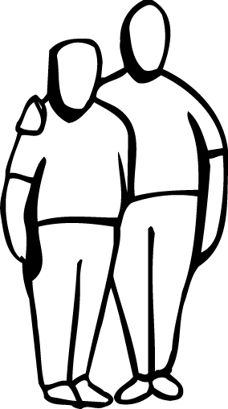

**JUVENILE TERMS**

_____________________

_____________________

_____________________

_____________________

_____________________

_____________________

_____________________

**ADULT TERMS**

_____________________

_____________________

_____________________

_____________________

_____________________

_____________________

_____________________

**Match the terms below to either the JUVENILE or ADULT above.**

Crime Admit being involved Delinquency Petition Trial Criminal Record Guilty

Disposition Charge with crime Offense

Hearing Juvenile record Sentence