ISSUES THAT MATTER TO ME – the Elementary Edition

Read each question and vote for the 3 issues that will matter most to you. Be prepared to explain your choice.

Mark your vote with an X in the blank.

_____ 1. Should there be more mountain bike trails in parks?
_____ 2. Should all cell phone use be banned (not allowed) while driving?
_____ 3. Should violent video games be banned (not allowed)?
_____ 4. Should there be laws protecting honey bees?
_____ 5. Should junk food be banned from school lunches?
_____ 6. Should bike helmets and bike safety classes be required?
_____ 7. Should the voting age be lowered to 16?
_____ 8. Should recess be required during the school day?
_____ 9. Should Minnesotans be allowed to keep wild animals (snakes, lizards) as pets?
_____10. Should more bike lanes be added to roads?

Review your top 3 votes and now decide which topic is THE MOST IMPORTANT to you. You will be asked to stand by this topic.

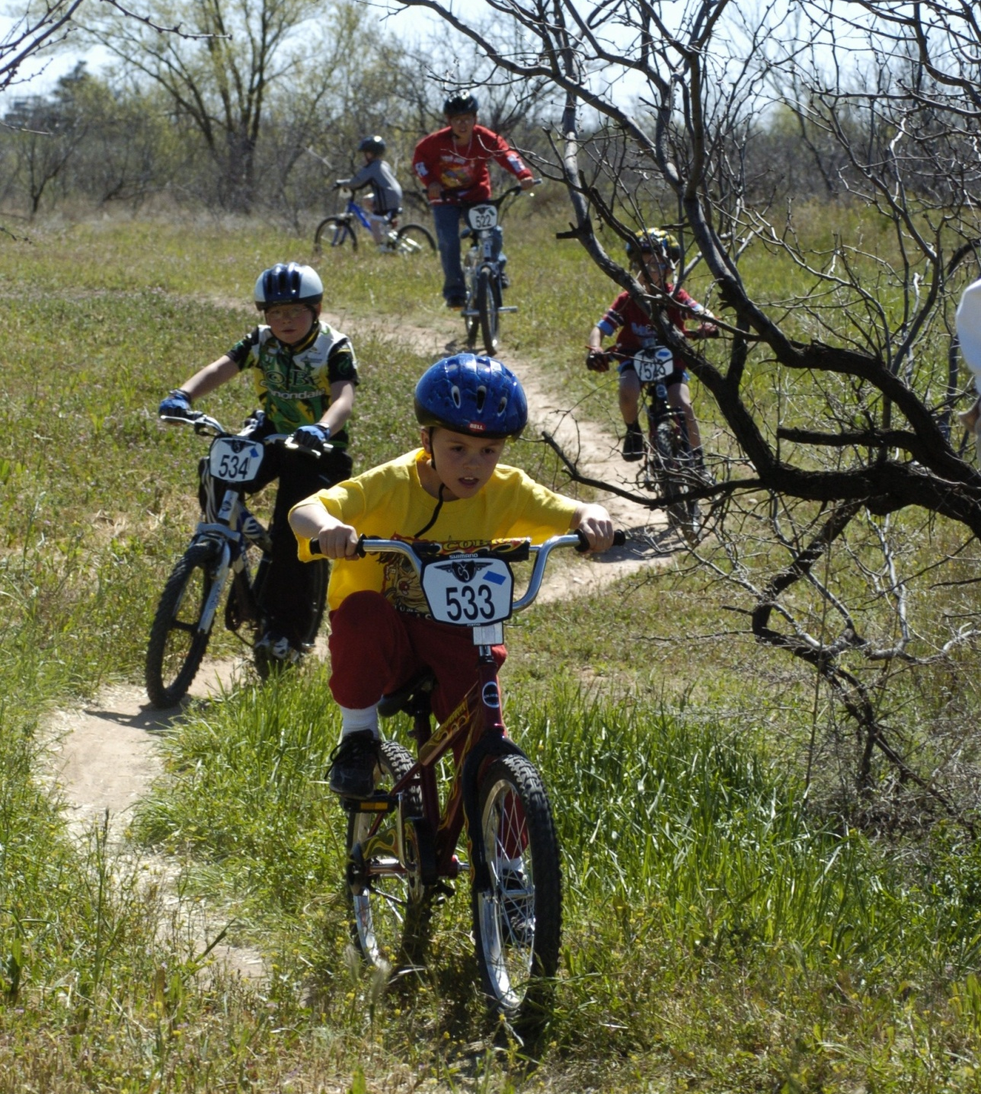

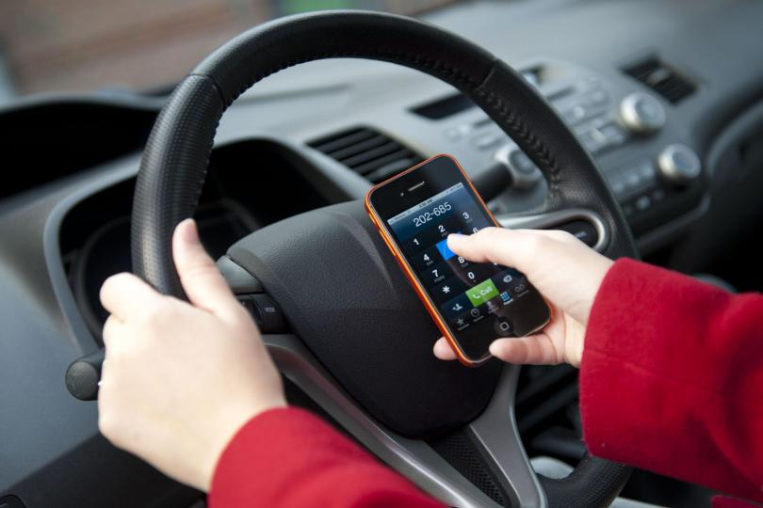

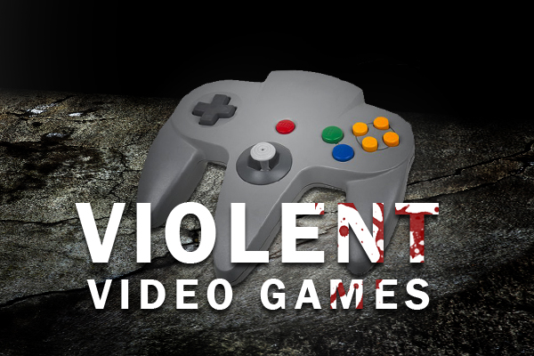
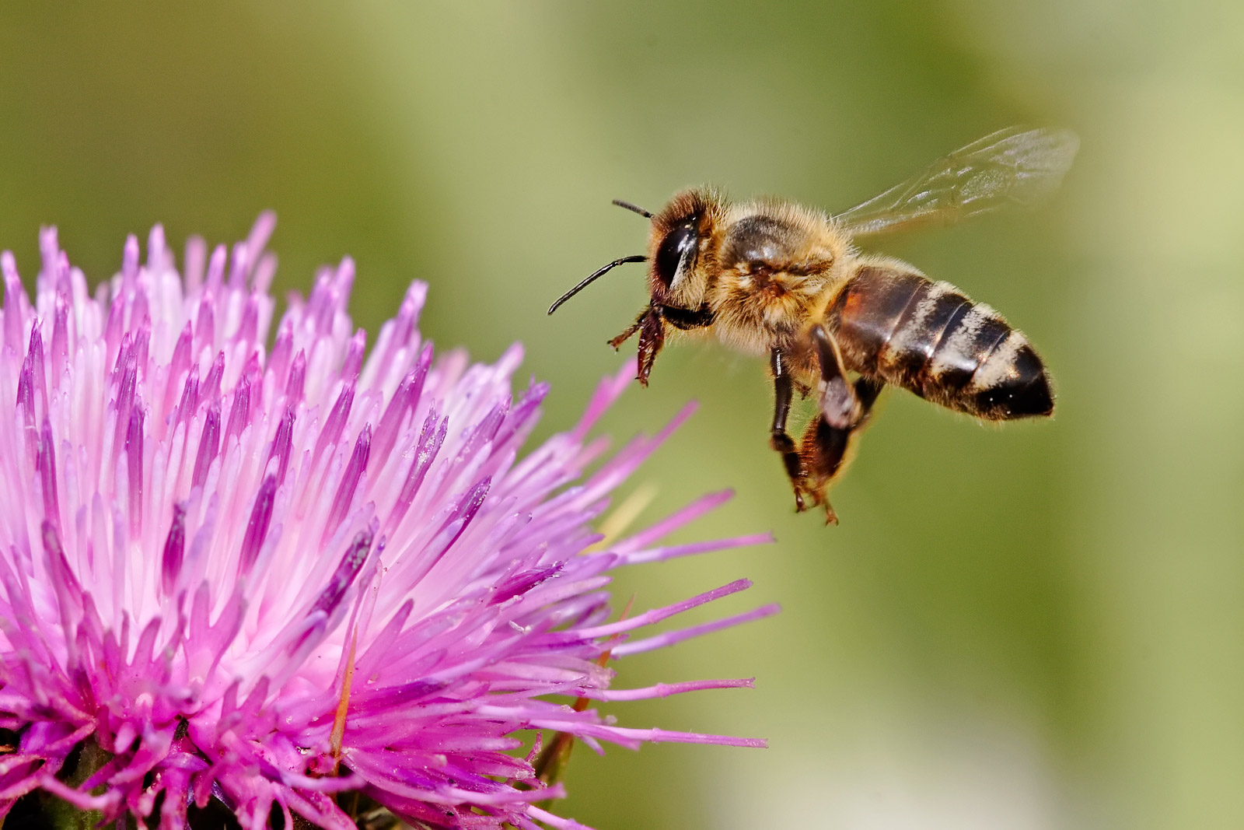

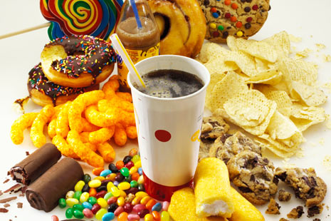

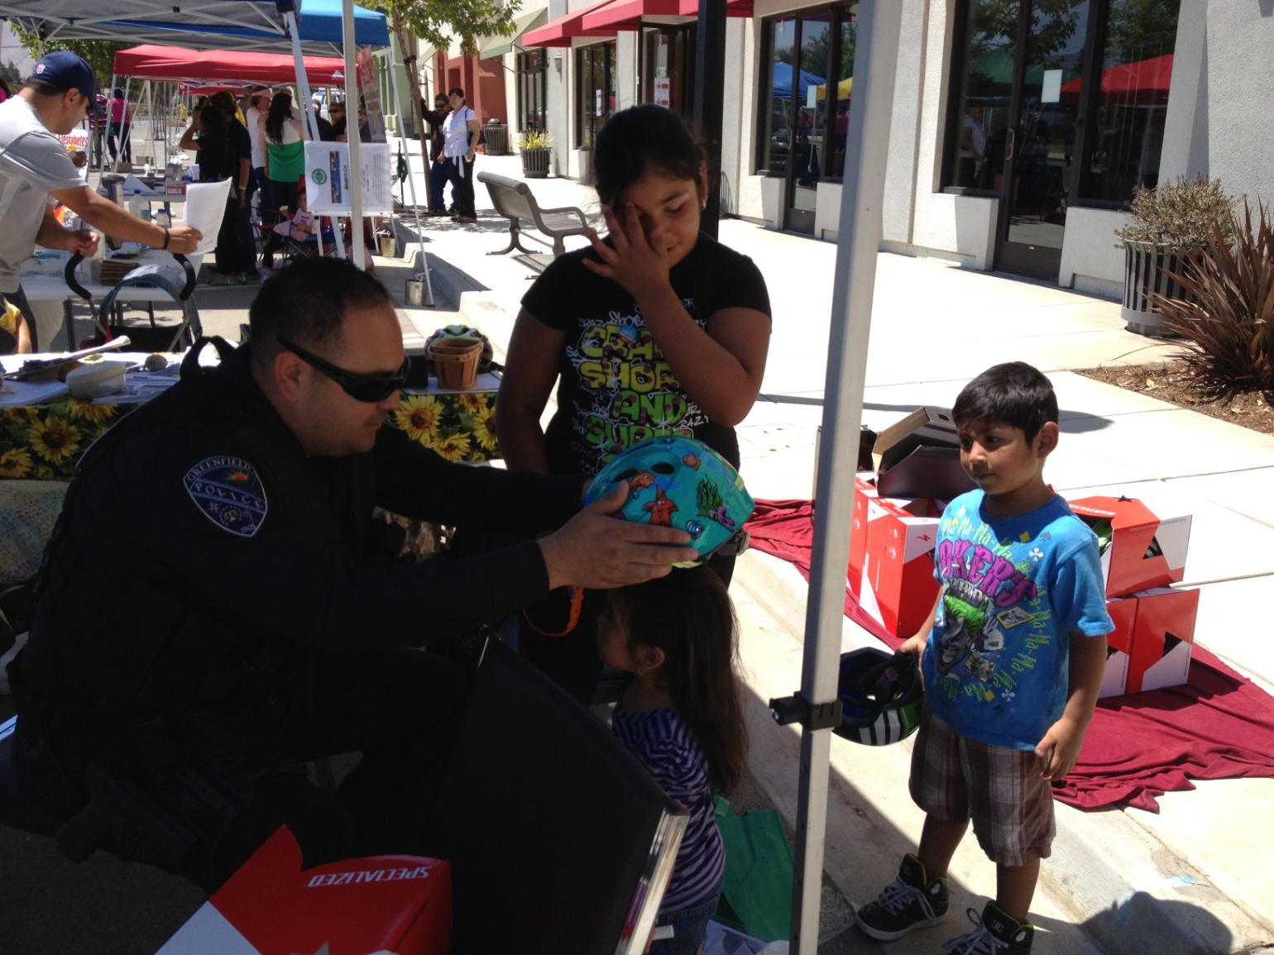

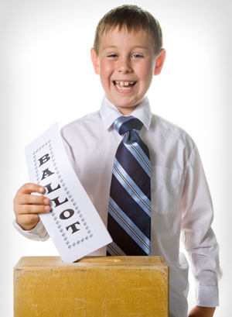

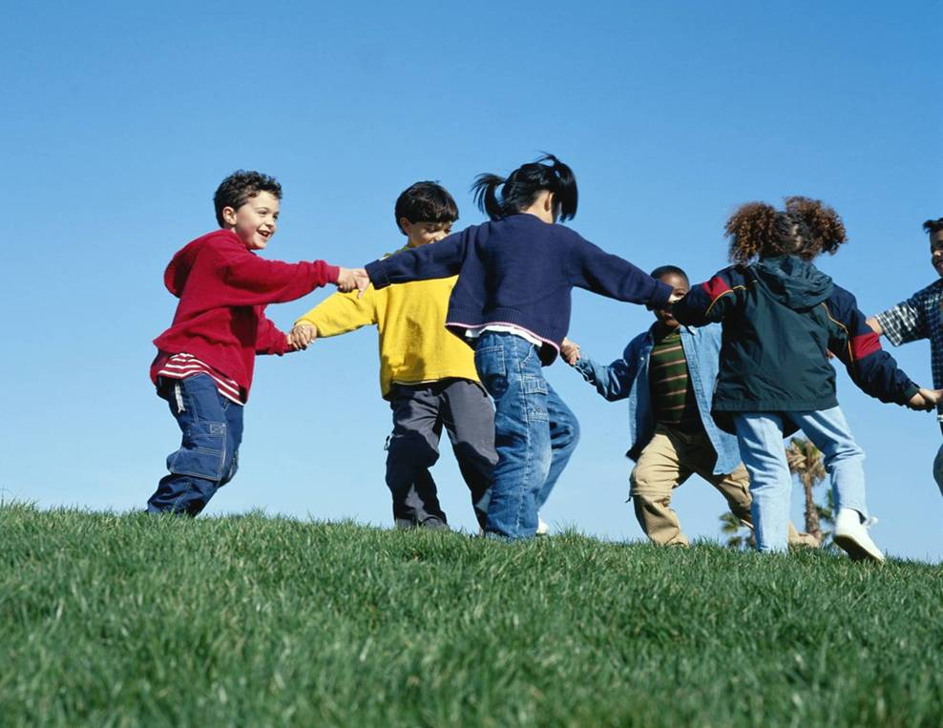

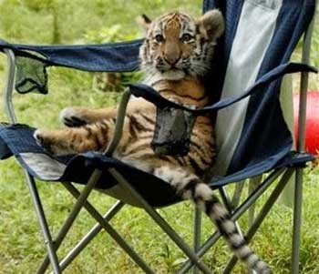

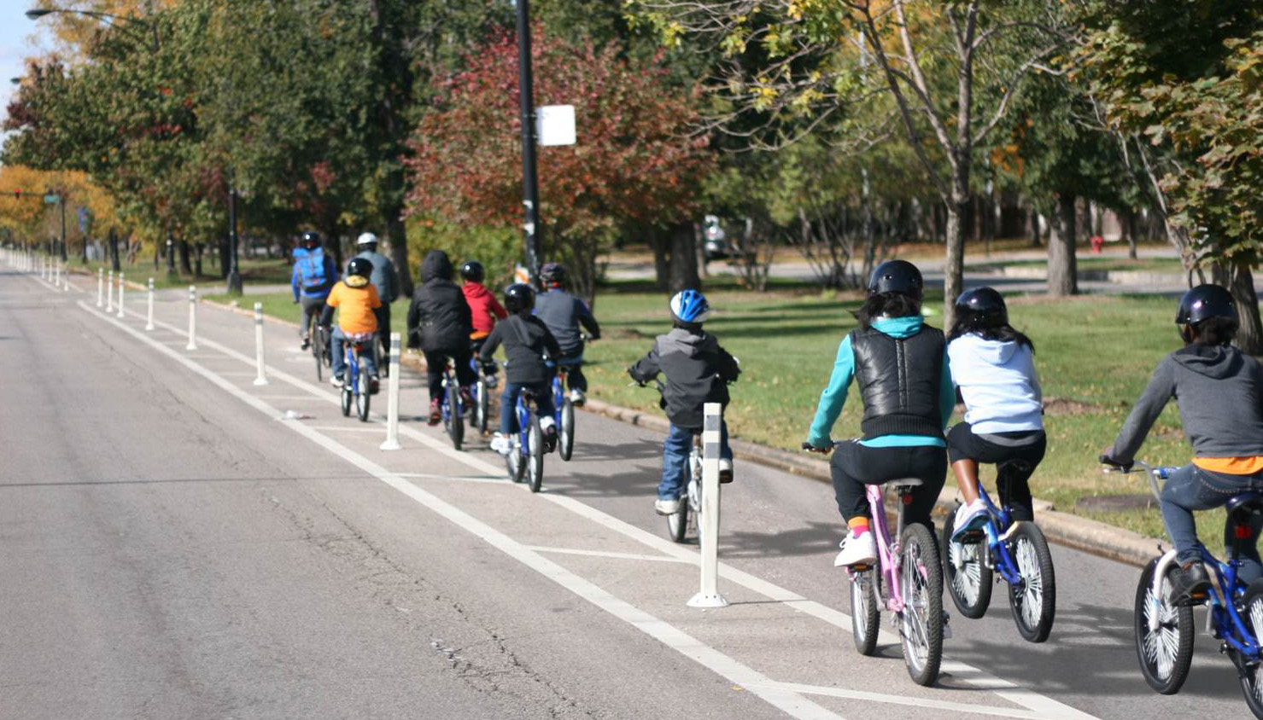

Sources of images:
1. http://www.mylubbock.us/images/parks-rec-images/mlk-mountain-bike-trail.jpg?sfvrsn=2
2. http://cdnph.upi.com/sv/b/upi/UPI-31341367141400/2013/1/05b041413f4d19413271bf93326a7350/April-is-National-Distracted-Driving-Awareness-Month.jpg
3. http://sourcefed.com/wp-content/uploads/2013/01/Violent-Video-Games.jpg
4. http://en.wikipedia.org/wiki/Bee
5. http://www.vitamedica.com/wp-content/uploads/2013/08/Sleep-Loss-Leads-to-Junk-Food-Cravings.jpg
6. http://marilynch.com/blog/wp-content/uploads/2012/08/IMG_1112.jpg
7. http://www.sheknows.com/parenting/articles/805956/raising-a-weepublican-or-a-demoquat-getting-your-kids-involved-in-politics
8. http://www.airquality.dli.mlsi.gov.cy/Images/Articles/Kids_corner/kids_playing.jpg
9. http://www.blurtit.com/var/question/q/q8/q83/q831/q8311/q8311022_1440161_307_babytiger
10. http://chicagocompletestreets.org/wp-content/uploads/2013/06/Lake-PBL.jpg

