Voting Matters to Me
The Why, Who, and How of Voting
A Four-Lesson Unit

Designed for high school students to inspire
them to become life-long voters

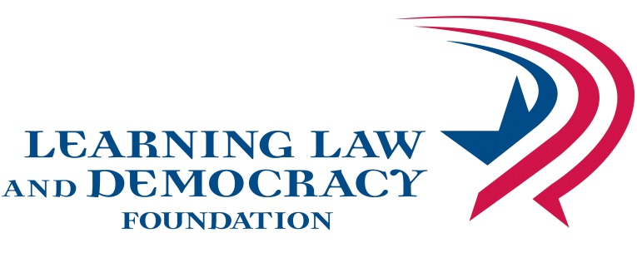

VOTING MATTERS TO ME

© 2014• Learning Law and Democracy Foundation
2395 University Avenue West, Suite 220, St. Paul, MN 55114

http://www.teachingcivics.org

Authors
JoEllen Ambrose
Jennifer Bloom
Alex Gray
Filiz Yargici

All rights reserved. Permission granted for nonprofit educational use

Voter Prep 101
This lesson teaches students how to prepare for voting. Students investigate the location of their polling place and learn about the different types of elections on the ballot. Students evaluate information about candidates and issues.
Grades: 9-12
Minnesota K-12 Academic Standards in Social Studies
9.1.1.1.1 Demonstrates skills that enable people to monitor and influence state, local and national affairs.
9.1.1.1.2 Demonstrate the skills necessary to participate in the election process including registering to vote, identifying and evaluating candidates and issues, and casting a ballot.
LEARNING OBJECTIVES
Students will be able to
- Identify reasons why people don’t vote and explore ways to remove obstacles to voting
- demonstrate skills of voter preparation in order to identify and evaluate candidates and issues.
- demonstrate skills that enable people to monitor and influence state, local and national affairs.
PROCEDURE
- Intro Activity: Class review on Why Vote? Brainstorm Why not vote? Suggest responses to the “why not’s”

- Some people don’t vote because they feel they are uninformed or don’t know enough about the candidates or issues. Today let’s see how we can become better informed voters.
- Voter Prep 101
- Where do you vote? - http://pollfinder.sos.state.mn.us/ to find your precinct voting place.

- What is on your ballot?
  - Quick exercise, ask class to raise their hand and vote:
Vote #1 Ice Cream yes _____ no _____
Toxic Waste yes _____ no _____
Now Vote #2 Tax on Ice Cream? yes _____ no _____
Clean up toxic waste? yes _____ no _____

Ask the group why their votes changed (because they had more information).

  - Get ready to vote by learning what is on the ballot at – http://myballotmn.sos.state.mn.us/ and find your sample ballot.

  - Learn about the different federal, state, county, city and other local offices as well as judicial elections. The Minnesota Legislative Manual at http://www.sos.state.mn.us/index.aspx?page=1744 provides descriptions and qualifications for state and federal offices. Go to local county and city websites to learn about local officials.

Note: 2014 has no referendums or proposed constitutional amendments on the ballot.

- Where do voters get information about voting, candidates and the issues?

- Who do you vote for? – In deciding who to vote for, one must locate information about the candidates and issues from a variety of sources. Careful consideration must be given to whether the information is partisan or nonpartisan.

Partisan sources are persuasive toward a particular candidate or stance on an issue. The source gives opinions and may try to convince you how to vote.

Nonpartisan sources give factual information, presents multiple perspectives and does not favor a particular candidate or stance on an issue.

Note: The way one gets information, like “television” or “the internet,” can be either partisan or nonpartisan depending on the source.

- Below are 10 sources of information. Identify whether they are Partisan (P) or Nonpartisan (NP). Be prepared to explain your answers.

_____ 1. Sample ballot
_____ 2. Family and friends
_____ 3. Newspaper editorial or “commentary”
_____ 4. Newspaper article
_____ 5. Candidate’s voting record at Project Vote Smart at www.vote-smart.org
_____ 6. Campaign advertisement on TV, mailed campaign literature or candidate’s website.
_____ 7. League of Women Voter’s candidate forums.
_____ 8. Endorsements from groups you trust
_____ 9. Newspaper voter’s guide
_____ 10. Televised candidate debates

- Evaluate websites (see checklist) at http://www.lib.umd.edu/binaries/content/assets/public/usereducation/evaluating-web-sites-checklist-form.pdf

- Political Parties may help you decide – Political parties support candidates who run on the party’s platforms. When becoming informed you can choose a party that has the same views as you do.
Take issues from voting matters to me and find the party planks on those issues. Students would see the 3 major parties in MN and check planks with which they agree.
Independence Party, Republican Party, Democratic-Farmer-Labor Party

Do your homework, don’t show up at the polls to google the election as you cast your ballot!

