Voting Matters to Me
The Why, Who, and How of Voting
A Four-Lesson Unit

Designed for high school students to inspire
them to become life-long voters

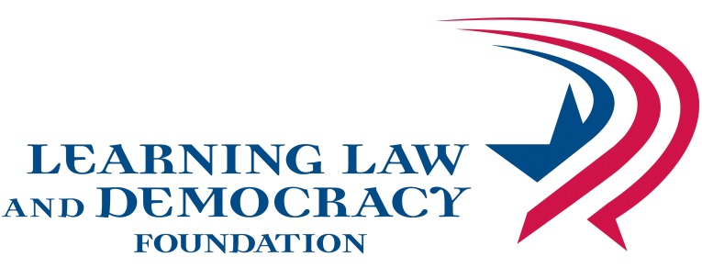

VOTING MATTERS TO ME

© 2014• Learning Law and Democracy Foundation
2395 University Avenue West, Suite 220, St. Paul, MN 55114

http://www.teachingcivics.org

Authors
JoEllen Ambrose
Jennifer Bloom
Alex Gray
Filiz Yargici

All rights reserved. Permission granted for nonprofit educational use

Contents

Unit Overview of Lesson 4
Overview of Lessons 5
Lesson One: Why Should Voting Matter to Me? 7
Issues That Matter to Me Survey and Signs 11
Voter Cards for Lesson 1 Activity 25
Lesson Two: Essentials of Voting 28
Essentials of Voting PowerPoint 31
Why? Who? How? Graphic Organizer 32
Voter’s Bill of Rights 33
Essentials of Voting Vocabulary 34
Sample Ballot 2014 General Election Ballot 37
Lesson Three: Voting as Easy as 1-2-3 39
Voter Scenario Cards 44
Voter Scenarios Answer Key 50
Diagram of Precinct Voting Station 57
Polling Place Signs 58
Greeter Judge Instructions 68
Roster Judge Instructions 69
Registration Judge Instructions 70
Demonstration Judge Instructions 72
Instructions for Voters 72
Ballot Judge Instructions 73
Ballot Counter Judge Instructions 74
I Voted Sticker Template 75
Roster of Registered Voters 76
Voter Oath 77
Voter Receipts 78
Small Group Voting Scenarios 79

Anticipation & Note Guide 84
Voter Prep 101 86

Unit Overview
This 3-4 day voting unit will prepare students to vote by showing students why voting matters to them on the issues they care about. It will inform students about Who? Why? and How? of voting. Students will experience the process of voting and key steps in becoming a prepared voter. Each lesson stands alone offering choice and flexibility for classroom use. The unit is adapted from updated election information available at the Minnesota Secretary of State’s website: www.sos.state.mn.us or www.mnvotes.org. Unit lessons can be found at www.teachingcivics.org.
Why teach this unit? A fundamental purpose of education is to prepare students for their role as active and engaged citizens by teaching the importance, skills and rights of voting.
Minnesota K-12 Academic Standards in Social Studies
9.1.1.1.1 Demonstrates skills that enable people to monitor and influence state, local and national affairs.
9.1.1.1.2 Demonstrate the skills necessary to participate in the election process including registering to vote, identifying and evaluating candidates and issues, and casting a ballot.
Unit Content Objectives
Students will be able to:
- examine current topics and rank how much the topic matters to them personally.
- evaluate the impact of voter turnout on the topics they care most about.
- understand information on why people vote, who votes and how people vote.
- apply voting information to precinct voting situations on an election day.
- demonstrate skills necessary to participate in the election process such as registering to vote and casting a ballot.
- demonstrate skills of voter preparation in order to identify and evaluate candidates and issues.
- demonstrate skills that enable people to monitor and influence state, local and national affairs.
Vocabulary
- See Election Vocabulary Handout
Assessments
- Graphic Organizer on Voting
- Anticipation/Note sheet on Voting as Easy as 1-2-3

Overview of Lessons
Lesson Activities | Learning Objectives | Materials
Lesson 1: Voting Matters to Me  (20 -30 minutes)  Ask students, why vote? Does it really matter to you?  Do lesson on “Voting Matters to Me”  Discuss issues in current election | Students will be able to:  - examine current topics and rank how much the topic matters to them personally.  - evaluate the impact of voter turnout on the topics they care most about. | Student Issue Survey, Voter Cards, Issue signs
Lesson 2: Essentials of Voting  (50 - 60 minutes)  Students complete a graphic organizer on voting  - Why do people vote?  - Who votes?  - How do you vote?  Show Powerpoint on Voting from MN Secretary of State  Election Vocabulary quizlet | Students will be able to:  - understand information on why people vote, who votes and how people vote. | Voting Graphic Organizer, Voting Powerpoint,  Sample Registration forms and sample ballots,  Election vocabulary and quizlet,  Voter’s Bill of Rights
Lesson 3: Voting as Easy as 1-2-3  (45-60 min.)  Students complete Anticipation/Note Guide  Class simulates a precinct voting station  OR  Small group exercise with voting scenarios  Debrief with Anticipation/Note Guide | Students will be able to:  - apply voting information to precinct voting situations on an election day.  - demonstrate skills necessary to participate in the election process such as registering to vote and casting a ballot. | Note Student Guide,  Voter Simulation power point, Election Judge Instructions, Voter Scenarios Handout, Polling place signs,  Voter Scenarios, Small-Group
Lesson 4: Voter Prep 101 (45-60 minutes)  Chart on voting obstacles and responses  Getting ready to vote  - where do I vote?  - what is on the ballot?  - who should I vote for?  Evaluate partisan and non-partisan sources of voter information  Evaluate websites with checklist | Students will be able to:  Identify reasons why people don’t vote and explore ways to remove obstacles to voting  demonstrate skills of voter preparation in order to identify, and evaluate candidates and issues.  - Evaluate sources of voter information in order to monitor local, state and national elections. | Evaluation of website checklist

